Project: Titan TV 2K 2026
AQ fine tuning
XML-XLS converter. Project Task
Application version 2.x

Prepared by: Alex Jermakov
Created: 2026 05 19
Updated: 2026 05 29

Scope: this document describes project task conditions, required for XML-XLS converter application to be created by Codex AI tool.

Note: This is project task modification for application version 2.x, which is simplified against the project task version 1.x, with target to use Copy+Past operation instead of full function app. Such decision must simplify application development. There are applied following modifications:

- Removed TV model selection
- Removed MAP file (it is used now internal file among project files)
- Removed selection of input XLS file
- Removed selection of output XLS file

Project Task

Create certain application under conditions described below.

General information

Application name: Sharp Titan TV. AQ. XML-XLS converter
Version: 2.7
Application type: web online application
Application URL: new one, different to the application of Version 1.x

Functionality: to analyze audio data inside of XML file and create data for manual Copy+Paste operation.
Descriptions:
- XML file is generated by Dolby Tuning Tool and it contains Dolby Audio Processing (DAP) settings. It is input file for the converter
- XLS output file must contain DAP settings in the format, acceptable for the manual implementation to XLS file by Copy&Paste operation
- Dependencies between data in XML file and in XLS files are described in the XML-XLS Dependencies file (named as MAP2.7).

General functionality

XML file description

In the XML file there must be identified the settings dedicated to internal speaker. These settings are located inside of the text portions, which starts with a string :

<endpoint type="internal_speaker" brand="Brand" model="TVMOdelName">.

And ending with a string:

</endpoint>

Note: Values “Brand” and “TV ModelName” may variate, they have no sense for identification.

There is one more endpoint defined by string <endpoint type="headphones" brand="user-editable" model="user-editable">, which is dedicated for headphones.

The application must operate only with data developed for internal speakers. Data for headphones must be out of scope.

In the XML file there is also important to identify the DAP audio settings, dedicated to different Sound Profiles.

DAP settings for every sound profile are located inside of the text portion, which is starting with string

<profile type="ProfileName" name="txtProfileName">

And it is ending with the string:

</profile>

Full list of all sound Profiled is shown in the table below. Profiles Game, Night and Off are excluded from the application scope.

Profile Name in XML file | Supported by application
Movie | yes
Music | yes
Game | no
Night | no
Voice | yes
User Selectable | yes
Off | no

MAP file

MAP file is file in XLSX format, which describe dependencies in between Sound Profiles and Sound parameter names in between XML and XLS files.

This file is the internal project file, which can be updated by developer, but it must be used for application built.

The file name is defined as MAP2.7.xlsx.

Title of this file is demonstrated below:

Output XLS file

Output file must be prepared in XLSX format and it must contain the data from XLM file and relevant data, generated for Copy&Paste operation. The name of the file is “Titan TV. DAP AQ. XML-XLS converter. Output.xlxs”

Title for this file is shown below. It is the same as for MAP file.

Parameters values must be found in the XML file. They are defined in Decimal format. Application must convert them to Hexadecimal format and put the value to the corresponding column named “GAIN(HEX)”.

Equalizers (EQ) parameters must be executed in different way. This requirement concerns three EQ types:

- Graphic EQ
- Graphic EQ(Wallmount)
- Intelligent EQ

For EQ parameters Band Fc (Center Frequency) there must be used the fixed values defined in the DTT tools, as shown on the screenshot below:

Resulted values are defined in the table below:

EQ Center frequency | HEX value | DEC value
Band_01_Fc | 0000002F | 47
Band_02_Fc | 0000008D | 141
Band_03_Fc | 000000EA | 234
Band_04_Fc | 00000148 | 328
Band_05_Fc | 000001D5 | 469
Band_06_Fc | 00000290 | 656
Band_07_Fc | 0000034C | 844
Band_08_Fc | 00000407 | 1031
Band_09_Fc | 00000521 | 1313
Band_10_Fc | 00000698 | 1688
Band_11_Fc | 000008CA | 2250
Band_12_Fc | 00000BB8 | 3000
Band_13_Fc | 00000EA6 | 3750
Band_14_Fc | 00001250 | 4688
Band_15_Fc | 000016B5 | 5813
Band_16_Fc | 00001BD5 | 7125
Band_17_Fc | 00002328 | 9000
Band_18_Fc | 00002BF2 | 11250
Band_19_Fc | 00003633 | 13875
Band_20_Fc | 00004CE8 | 19688

The EQ Band Target values must be copied from the XML file field dedicated to EQ band, see example below:

<graphic-equalizer-bands value="0,26,30,0,0,0,0,0,0,18,32,28,22,0,0,0,0,0,0,0"/>

For this text string the EQ Target values must be defined as in the table below:

EQ Center frequency | HEX value | DEC value | Target value
Band_01_Target | 0000002F | 47 | 0
Band_02_Target | 0000008D | 141 | 26
Band_03_Target | 000000EA | 234 | 30
Band_04_Target | 00000148 | 328 | 0
Band_05_Target | 000001D5 | 469 | 0
Band_06_Target | 00000290 | 656 | 0
Band_07_Target | 0000034C | 844 | 0
Band_08_Target | 00000407 | 1031 | 0
Band_09_Target | 00000521 | 1313 | 0
Band_10_Target | 00000698 | 1688 | 18
Band_11_Target | 000008CA | 2250 | 32
Band_12_Target | 00000BB8 | 3000 | 28
Band_13_Target | 00000EA6 | 3750 | 22
Band_14_Target | 00001250 | 4688 | 0
Band_15_Target | 000016B5 | 5813 | 0
Band_16_Target | 00001BD5 | 7125 | 0
Band_17_Target | 00002328 | 9000 | 0
Band_18_Target | 00002BF2 | 11250 | 0
Band_19_Target | 00003633 | 13875 | 0
Band_20_Target | 00004CE8 | 19688 | 0

The same method must be used for all three types of EQ.

The EQ Band Target values for Intelligent EQ must be copied from the XML file field dedicated to EQ band, see example below:

<ieq-bands value="157,164,219,218,204,188,192,192,212,214,219,211,197,161,136,96,72,25,-92,-283"/>

For this text string the EQ Target values must be defined as in the table below:

EQ Center frequency | HEX value | DEC value | Target value
Band_01_Target | 0000002F | 47
Band_02_Target | 0000008D | 141 | 164
Band_03_Target | 000000EA | 234 | 219
Band_04_Target | 00000148 | 328 | 218
Band_05_Target | 000001D5 | 469 | 204
Band_06_Target | 00000290 | 656 | 188
Band_07_Target | 0000034C | 844 | 192
Band_08_Target | 00000407 | 1031 | 192
Band_09_Target | 00000521 | 1313 | 212
Band_10_Target | 00000698 | 1688 | 214
Band_11_Target | 000008CA | 2250 | 219
Band_12_Target | 00000BB8 | 3000 | 211
Band_13_Target | 00000EA6 | 3750 | 197
Band_14_Target | 00001250 | 4688 | 161
Band_15_Target | 000016B5 | 5813 | 136
Band_16_Target | 00001BD5 | 7125 | 96
Band_17_Target | 00002328 | 9000 | 72
Band_18_Target | 00002BF2 | 11250 | 25
Band_19_Target | 00003633 | 13875 | -92
Band_20_Target | 00004CE8 | 19688 | -283

There must be used following XML strings for all possible XLS EQ types as defined in the table below:

XML profile type | XML string | XLS preset name | XLS EQ type description
Movie | graphic-equalizer-bands | Entertainment Custom mode | Graphic EQ
Movie | graphic-equalizer-bands | Entertainment Custom mode | Graphic EQ (Wallmount)
Movie | ieq-bands | Entertainment Custom mode | Intelligent EQ
Music | graphic-equalizer-bands | Music Custom mode | Graphic EQ
Music | graphic-equalizer-bands | Music Custom mode | Graphic EQ (Wallmount)
Music | ieq-bands | Music Custom mode | Intelligent EQ
Voice | graphic-equalizer-bands | Dialogue Custom mode | Graphic EQ
Voice | graphic-equalizer-bands | Dialogue Custom mode | Graphic EQ (Wallmount)
Voice | ieq-bands | Dialogue Custom mode | Intelligent EQ
User Selectable | graphic-equalizer-bands | Personal Custom mode | Graphic EQ
User Selectable | graphic-equalizer-bands | Personal Custom mode | Graphic EQ (Wallmount)
User Selectable | ieq-bands | Personal Custom mode | Intelligent EQ

To provide better end user experience, add to the XLS file title information like shown below:

Application name: Sharp Titan TV. AQ. XML-XLS converter
Version: 2.0
Conversion date: <actual date and time>
Input file name: <XML file name>
Output file name: <XLS file name>

Add to the file top this text, shown below:

User Instruction: Use the manual Copy&Paste operation by following steps:
- Select required Sound Mode in the column D (named as DSP)
- Select whole data from the column “GAIN(HEX)”
- Open AQ.XLS file
- Filter corresponding sound mode in the AQ.xls file
- Select required TV model in the column
- Paste selected values to this column
- Repeat steps 5-6 for other TV models, if required

The full step by step instruction must be presented in the title of output file, to help end users to execute Copy and Paste operation by correct way.

LOG file

LOG file must indicate internal operations of the application. Log data must be able to be collected in output LOG file.

User interface

User interface contains several windows, distributed on different screen location:

1.Title window with name of the application, version number, released date. It is located on the top of the screen.
2. Input window for XML file, located on the left side. It must support drag and drop technology
3. Output window for XLSX file. Located on the right side. It must support drag and drop technology.
4. Button “Convert”, located on the bottom of the screen, in the center
5. Button “Download output XLSX file”, located on the bottom of the screen, on the right. If must be enabled, if output file is generated successfully.
6. Button “Download Log”. Located on the bottom.
7. Progress bar indicator of the conversion process, located on the screen bottom
8. Window for application error, status and debug messages, on the screen bottom

Customer modifications, requested to be implemented in version 2.6:

- Add author name “Alex Jermakov” to the screen top, to the right side.

1. Output values need to be in DEC because original xml file for TITAN accepts to paste DEC values not HEX:
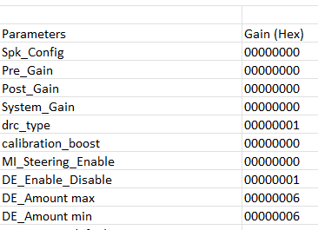
in .xls I need to paste here into dec column, then HEX is calculated, much better fs output file have in column 7 DEC values.
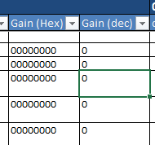
1A: manual can be removed:

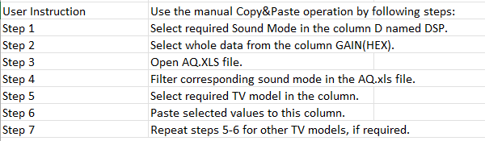
it is impossible to filter in original XLS file, then HEX values are not useful.
most important step here is, this manual needs 1 steps:
One step manual:
1. Use the “DEC” column and copy its contents (656 cells) into AQ.xls, starting from row 1166 (entertainment Custom Mode), into the “Gain (Dec)” column corresponding to the currently tuned TV model.
2. correction in Dialogue enhancer:
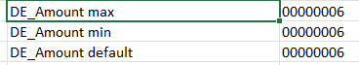
DE Amount default is taken form XML.
max and min values are constant, decimal 0 and 16
3. Correction in Surround boost:
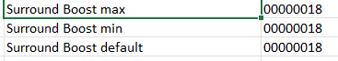
Default value is taken from XLM, max and min are constant, decimal: 0 and 96
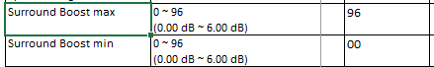
4. Correction o Bass Enhancer
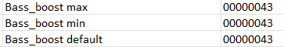
default value is taken form XLM. Max and min are constant:
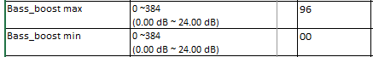
5. Inteligent IEQ value:
this need to be taken from here:

6. Speaker angle:

Take form here, don’t have to default

7. Virtual Bass
virtual bass values can be taken form xml, but it is not mandatory for now.
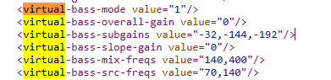

Customer modifications, requested to be implemented in version 2.7:

Reason 1: Max values were forced from Version 2.6 task text
Rows affected:
G21, G185, G349, G513: DE_Amount max
Converter output: 163
Marked expected/comment value: 16
Rows affected:
G29, G193, G357, G521: Surround Boost max
Converter output: 964
Marked expected/comment value: 96
Why: the app has hard-coded Version 2.6 rules:
- DE_Amount max -> 163
- Surround Boost max -> 964
But the attached XLSX marks these as wrong and indicates the MAP/default max values should remain:
- DE_Amount max -> 16
- Surround Boost max -> 96
So this is a requirement conflict: the Version 2.6 document said 163 and 964, but the claim file expects 16 and 96.

